visual wireframe
BizJump Client Dashboard
System Name: Business Command Center

- DASHBOARD HOME (MAIN VIEW)
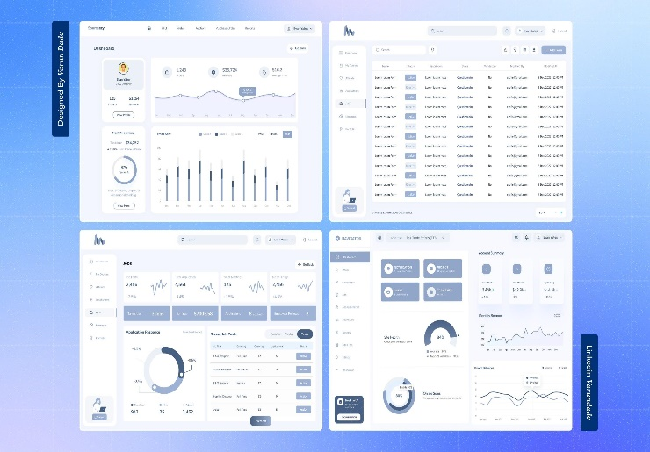 | 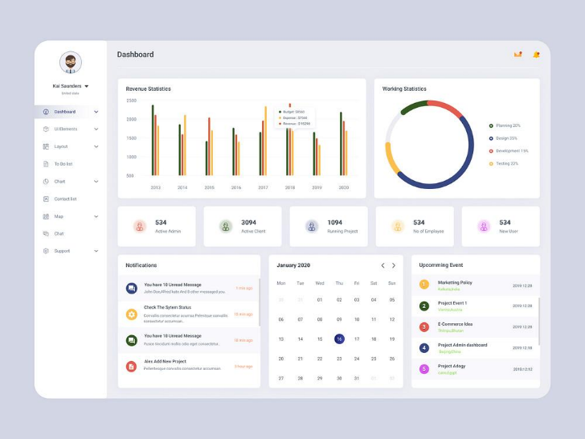

Layout Structure
Top Bar
- Logo (left)
- Notifications | Support | Account (right)
Sidebar (Left)
- Dashboard
- Documents
- Compliance
- Services
- Action Plan
- Messages
- Settings

Main Content Grid
LEFT COLUMN (70%)
[Business Status Card]
- Business Name
- Entity Type
- State
- Filing Status (progress bar)
- EIN Status

[Action Plan – Next Steps]
- Checklist:
  - Apply for EIN
  - Download Documents
  - Open Bank Account
  - Set Up Compliance
Button: View Full Action Plan

RIGHT COLUMN (30%)
[Quick Summary Card]
- Formation Progress %
- Next Deadline
- Active Services Count

[Notifications Panel]
- Filing update
- Reminder alerts
- DOCUMENT HUB
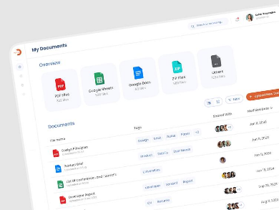 | 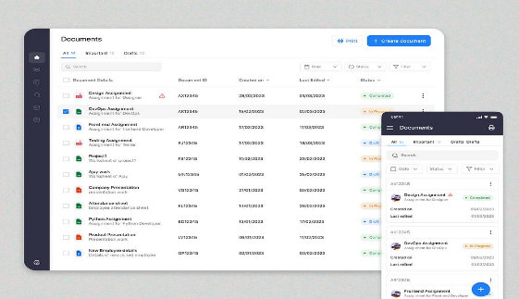 | 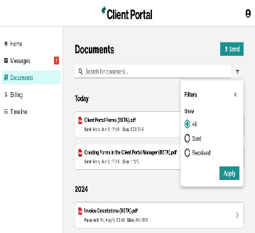 | 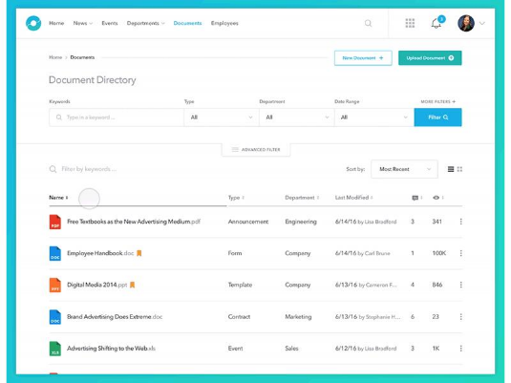

Layout
Header
Your Business Documents
Main Table
Document | Type | Date | Status | Action
Buttons
- Upload Document
- Download All

UX Behavior
- Click row → preview document
- Status tags: Ready / Pending / Processing

- COMPLIANCE CENTER

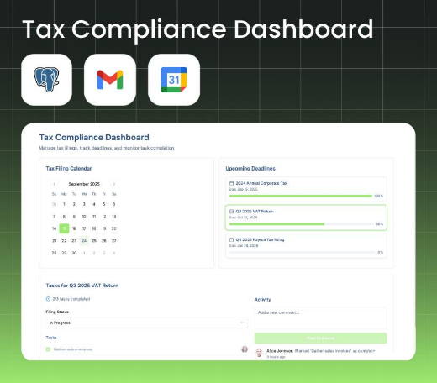 | 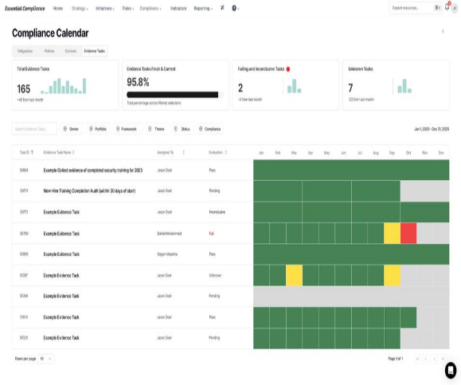 | 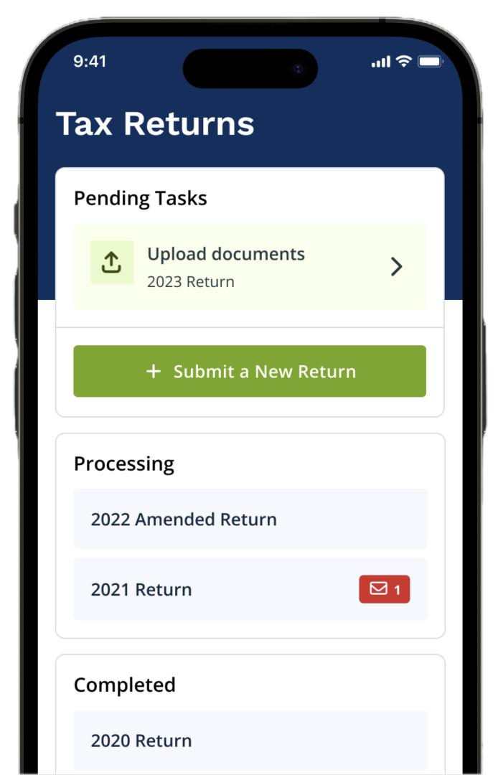

Layout
Top Section: Alerts
- Annual Report Due
- Tax Filing Reminder
- State Requirement
Status Colors:
- Green → On Track
- Yellow → Action Needed
- Red → Overdue

Calendar View
- Monthly compliance timeline

Buttons
- View Full Calendar
- Add Compliance Service
- SERVICE MANAGEMENT PANEL

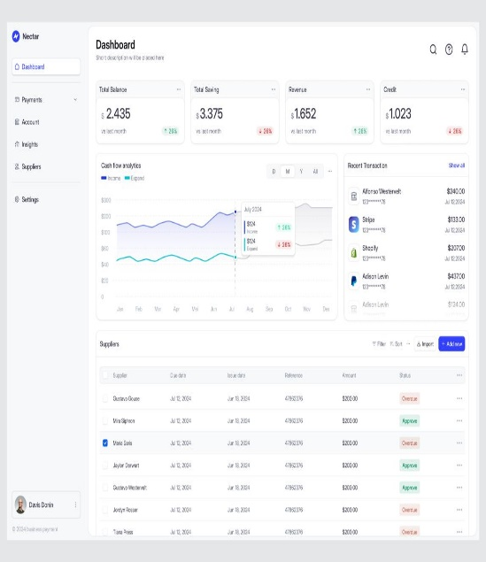 | 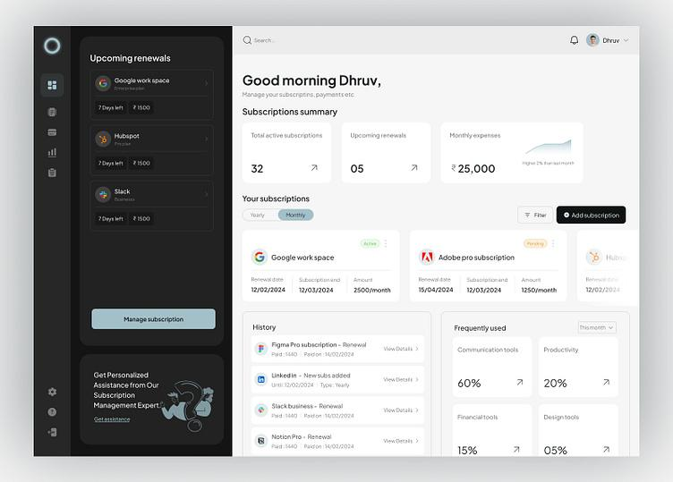 | 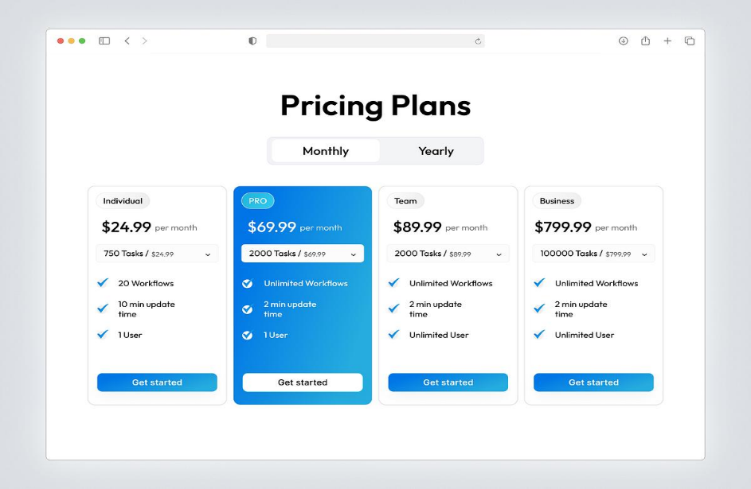

Layout
Active Services (Top)
- Formation Package
- EIN Filing
- Registered Agent

Available Add-Ons (Cards)
- Operating Agreement
- Bank Setup
- Social Media Setup
- Google Business Setup

Buttons
- Add Service
- Upgrade Package

- ACTION CENTER
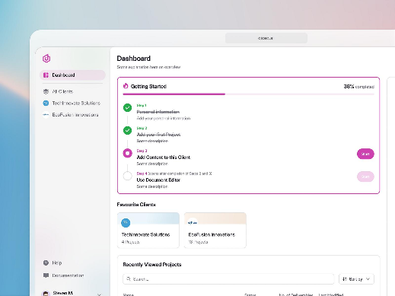 | 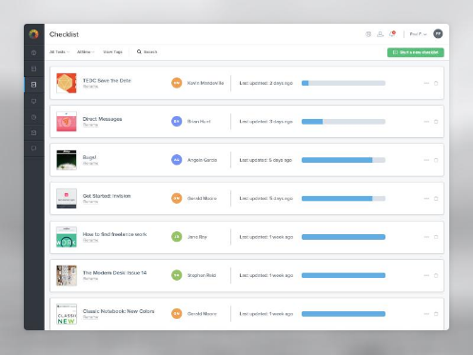 | 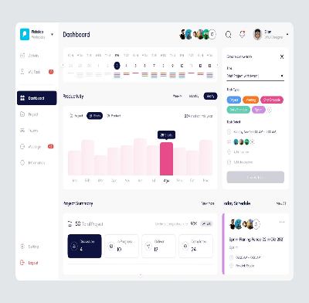
Layout
Tabs or Sections
Setup
- EIN
- Bank Account
- Accounting
Growth
- Social Media
- Google Business
- Website
Compliance
- Annual Reports
- Tax Filings

Interaction
- Checkbox → Mark Complete
- Expand → View instructions

- COMMUNICATION HUB
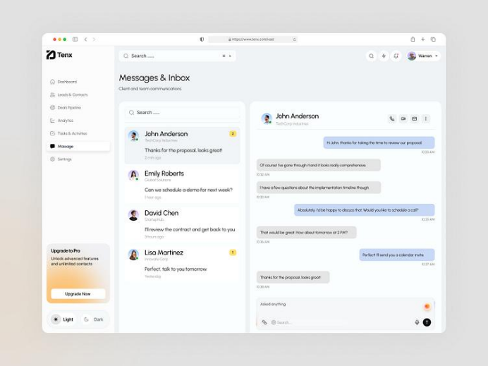 | 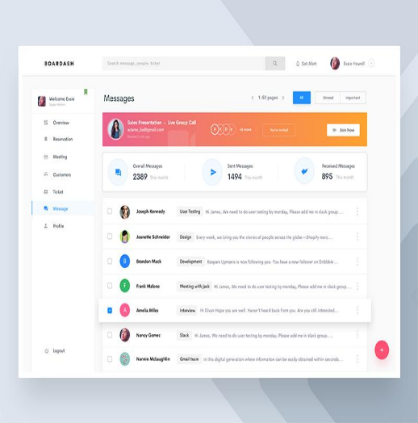 | 

Layout

Left Panel

Conversations list

Main Panel

Message thread with BizJump
Buttons
Send Message
Upload File

- BUSINESS PROFILE PAGE

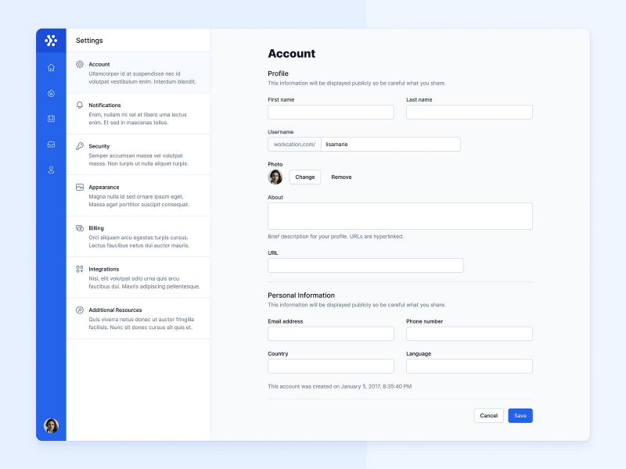 | 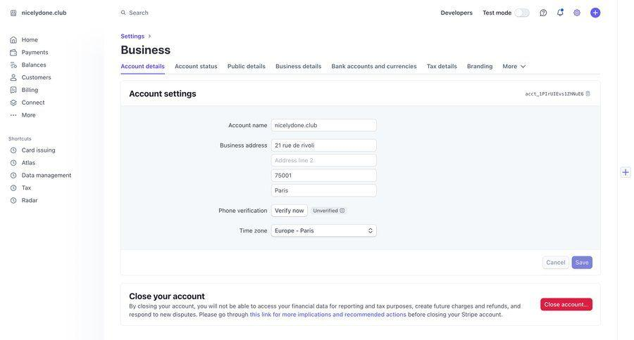 | 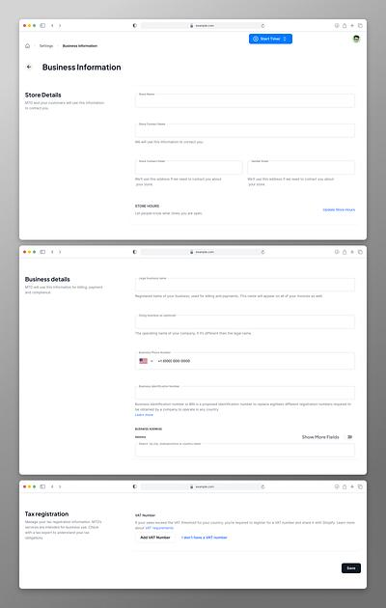

Layout
Fields
Business Name
Entity Type
State
EIN
Formation Date
Button

Edit Information

